ML Lab Assignments

Name: Ayushi Parikh Class: TY CSE IS II Roll No: 2193073
Enrolment No: MITU19BTCS0199

ASSIGNMENT 1

Aim: Installation and Configuration of machine learning environment with Anaconda on Ubuntu (Jupyter notebook)
Objective: To install anaconda and configure it with Python

Theory:
Installation Of Anaconda in Ubuntu:
- Visit the Anaconda downloads page
- Select Linux
- 3. Copy the bash (.sh file) installer link
- Use wget to download the bash installer
- Run the bash script to install Anaconda3
- source the .bash-rc file to add Anaconda to your PATH

NUMPY/SCIPY:-
- NumPy is a Python library, which stands for ‘Numerical Python’.
- It is the core library for scientific computing, which contains a powerful n-dimensional array object, provide tools for integrating C, C++ etc.
- NumPy array can also be used as an efficient multi-dimensional container for generic data.
- The ndarray (NumPy Array) is a multidimensional array used to store values of the same datatype. These arrays are indexed just like Sequences, starting with zero.
- The ndarrays are better than regular arrays in terms of faster computation and ease of manipulation.
- In different algorithms of Machine Learning like K-means Clustering, Random Forest etc. we have to store the values in an array. So, instead of using a regular array, ndarray helps us to manipulate and execute easily.

Installation Of NumPy - pip3 install numpy , Import numpy as np
- Installation of Scipy-stack - pip3 install scipy-stack

SCIKIT:-
The functionality that scikit-learn provides include:
- Regression, including Linear and Logistic Regression
- Classification, including K-Nearest Neighbors
- Clustering, including K-Means and K-Means++
- Model selection
- Preprocessing, including Min-Max Normalization.

Installation of scikit pip3 install -u scikit-learn

PANDAS:-
With Python Pandas, it is easier to clean & wrangle with your Data. features of Pandas make it a great choice for Data Science and Analysis.
- Merging and Joining Data Sets.
- Reshaping & pivoting Data Sets.
- Inserting & deleting columns in Data Structure.
- Aligning data & dealing with missing data.
- Iterating over a Data set.

- Analyzing Time Series.
- Filtering Data around a condition.
- Arranging Data in an ascending & descending.
- Reading from files with CSV, TXT, XLSX, and other formats.
- Manipulating Data using integrated indexing for DataFrame objects.
- Generating Data range, date shifting, lagging, converting frequency, and other other Time Series functionality.
- Subsetting fancy indexing, & label based slicing Data Sets that are large in size.
- Performing split apply combine on Data Sets using the group by engine.

Installation of Pandas - pip3 install pandas

MATPLOTLIB:-
- Matplotlib is a visualization library in Python for 2D plots of arrays. It consists of several plots like line, bar, scatter, histogram etc.
- Matplotlib is a multi-platform data visualization library built on NumPy arrays and designed to work with the broader SciPy stack.It can also be
- used with graphics toolkits like PyQt and wxPython. One of the advantages of visualization is that it allows us visual access to huge amounts of data in easily digestible visuals.

Installation of Matplotlib - pip3 install matplotlib



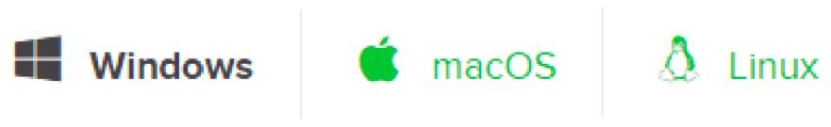





Conclusion:
Thus we have successfully installed Anaconda on windows and Ubuntu; We also have described the libraries and the installation of the libraries.

ASSIGNMENT 2

Aim: Download any dataset from any data repositories and perform the basic data pre-processing steps

Objectives:
- Learn to pre-process dataset
- Learn to use pandas and sklearn

Theory:
Basic steps to pre-process a dataset:
Step 1. Import the libraries Step 2. Import the data-set
Step 3. Check out the missing values Step 4. See the Categorical Values
Step 5. Splitting the data-set into Training and Test Set

Data cleaning:
- The main aim of Data Cleaning is to identify and remove errors & duplicate data, in order to create a reliable dataset.
- This improves the quality of the training data for analytics and enables accurate decision-making.
- There are various methods to identify and classify data for data cleansing.
- There are mainly two distinct techniques: Qualitative and Quantitative techniques to classify data errors.
  - Qualitative techniques involve rules, constraints, and patterns to identify errors.
  - Quantitative techniques employ statistical techniques to identify errors in the trained data.

Feature Scaling:
Feature scaling is one of the most important data pre-processing steps in machine learning. Algorithms that compute the distance between the features are biased towards numerically larger values if the data is not scaled.
There are some feature scaling techniques such as Normalization and Standardization that are the most popular.

Normalisation:
Normalization is a scaling technique in which values are shifted and rescaled so that they end up ranging between 0 and 1.
It is also known as Min-Max scaling.
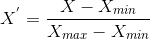

Here, Xmax and Xmin are the maximum and the minimum values of the feature respectively.
- When the value of X is the minimum value in the column, the numerator will be 0, and hence X’ = 0
- when the value of X is the maximum value in the column, the numerator is equal to the denominator and
thus the value of X’= 1
- If the value of X is between the minimum and the maximum value, then the value of X’ is between 0 and 1

Standardisation:
Standardization is another scaling technique where the values are centered around the mean with a unit standard deviation.
This means that the mean of the attribute becomes zero and the resultant distribution has a unit standard deviation.
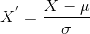
μ is the mean of the feature values and is the standard deviation of the feature values. The values are not restricted to a particular range.

Data Encoding:
Encoding is a technique of converting categorical variables into numerical values so that it could be easily fitted to a machine learning model.
- One Hot Encoding
- Nominal Categorical Variable
- Ordinal Categorical Variable
- Label Encoding
- Mean Encoding

Code and Output:

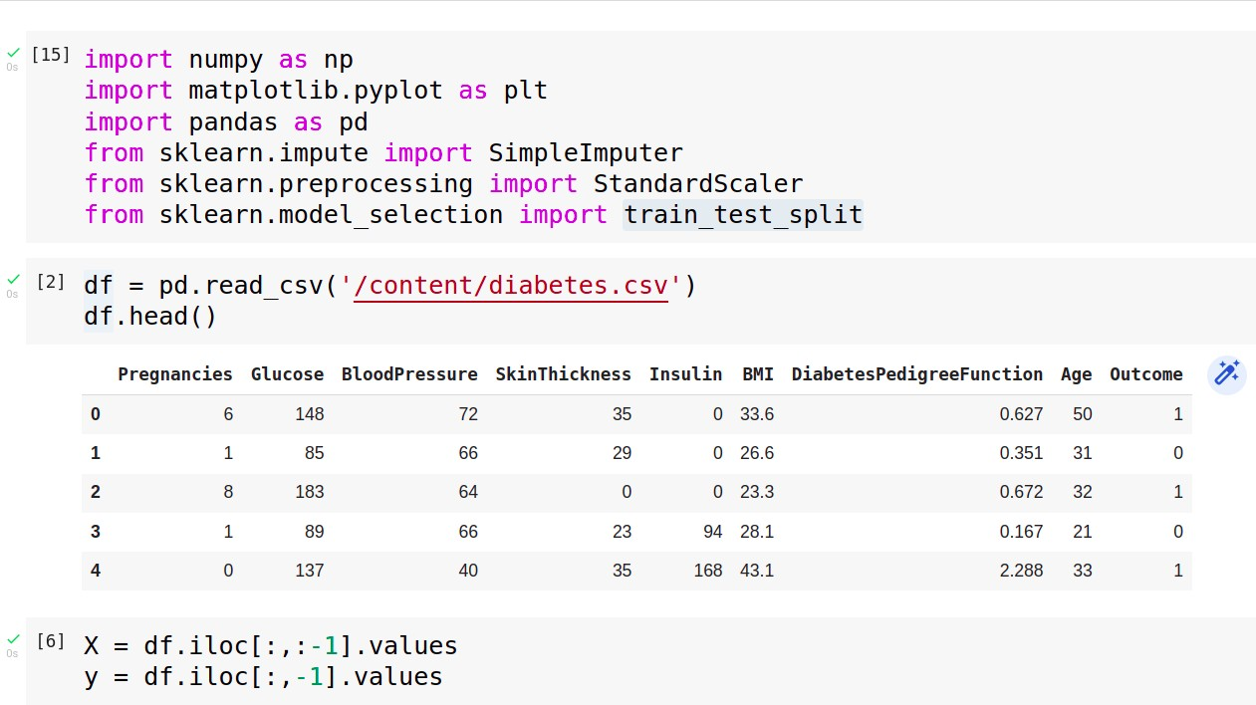

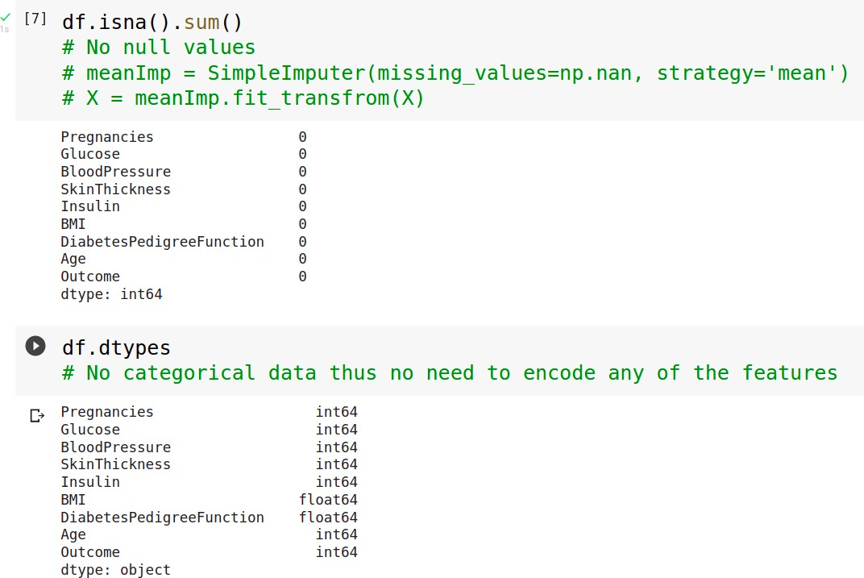

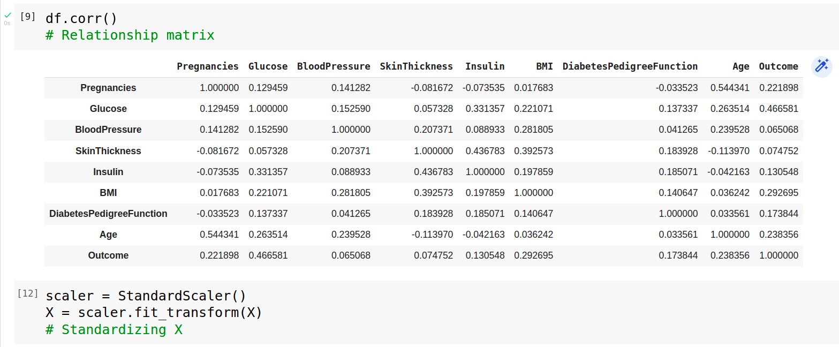
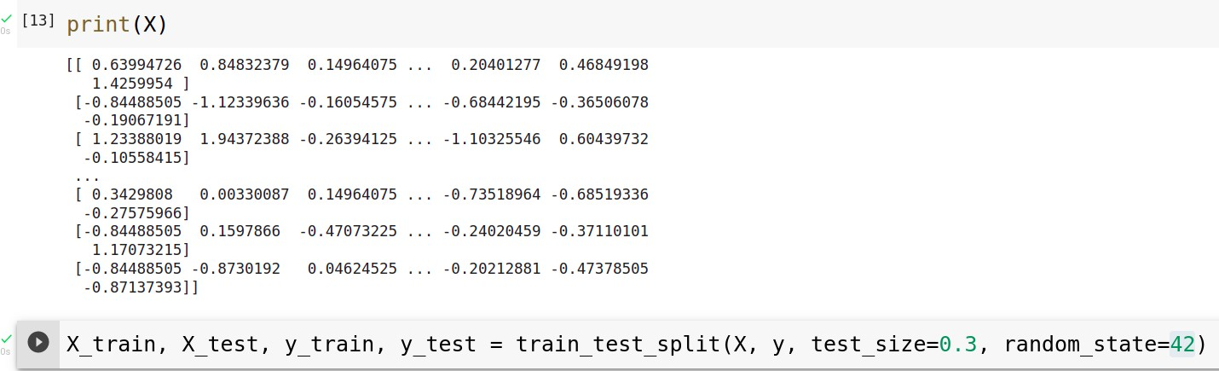

Conclusion:
Thus we have successfully implemented pre-processing operations on a dataset

ASSIGNMENT 3
Aim: Download any dataset from UCI or Data.org or from any other data repositories and Implement Single and multilayer perceptron on a dataset.

Objectives:
- To learn about classification and regression
- To learn MLP and backpropagation
- To demonstrate and analyse the results

Theory:
- Regression:
⇒ A regression problem is when the output variable is a real or continuous value, such as “salary” or “weight”.
⇒ Many different models can be used, the simplest is linear regression. It tries to fit data with the best hyper-plane which goes through the points.

Classification:
⇒ A classification problem is when the output variable is a category, such as “red” or “blue” or “disease” and “no disease”.
⇒ A classification model attempts to draw some conclusion from observed values. Given one or more inputs a classification model will try to predict the value of one or more outcomes.
⇒ For example, when filtering emails “spam” or “not spam”, when looking at transaction data, “fraudulent”, or “authorized”.

Multilayer Perceptron:
⇒ In the Multilayer perceptron, there can be more than one linear layer (combinations of neurons). If we take the simple example the three-layer network,
  - The first layer will be the input layer
  - The last layer will be output layer
  - The middle layer will be called the hidden layer.
⇒ We feed our input data into the input layer and take the output from the output layer.
⇒ We can increase the number of the hidden layer as much as we want, to make the model more complex according to our task.

Backpropagation Algorithm:
⇒ The algorithm is used to effectively train a neural network through a method called chain rule. In simple terms, after each forward pass through a network, backpropagation performs a backward pass while adjusting the model’s parameters (weights and biases).
⇒ Backpropagation aims to minimize the cost function by adjusting the network's weights and biases. The level of adjustment is determined by the gradients of the cost function with respect to those parameters.

Activation function:

⇒ Activation functions, also known as non-linearity, describe the input-output relations in a non-linear way. This gives the model power to be more flexible in describing arbitrary relations.
⇒ Here are some popular activation functions: Sigmoid, Relu, TanH.

Precision:
⇒ Precision is the ratio of correctly predicted positive observations to the total predicted positive observations.

F1 score:
⇒ F1 Score is the weighted average of Precision and Recall. Therefore, this score takes both false positives and false negatives into account.
⇒ F1 is usually more useful than accuracy, especially if you have an uneven class distribution.
⇒ Accuracy works best if false positives and false negatives have similar cost. If the cost of false positives and false negatives are very different, it’s better to look at both

Confusion matrix
⇒ A confusion matrix is a summary of prediction results on a classification problem.
⇒ The number of correct and incorrect predictions are summarized with count values and broken down by each class. This is the key to the confusion matrix.
⇒ The confusion matrix shows the ways in which your classification model is confused when it makes predictions. It gives us insight not only into the errors being made by a classifier but more importantly the types of errors that are being made.

Code and Output:
- MLP Regressor:
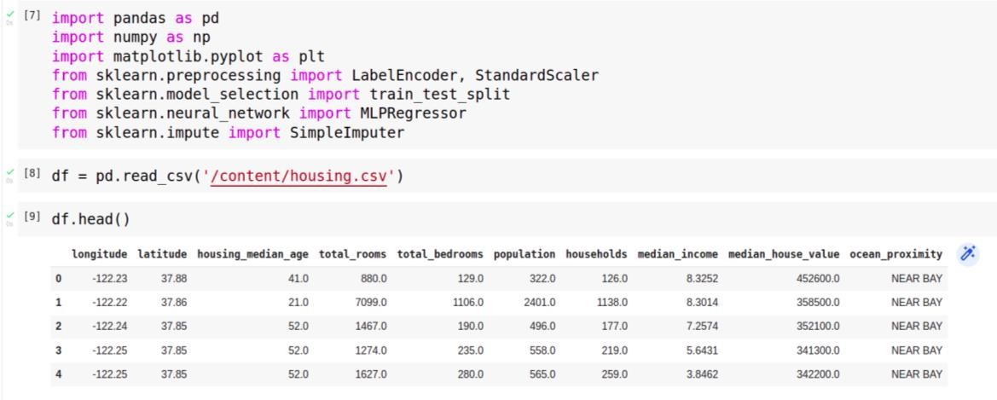
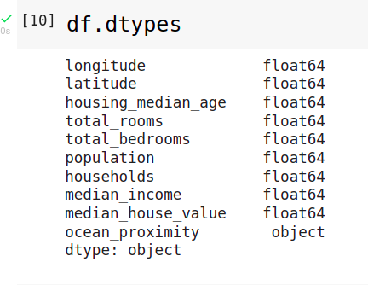

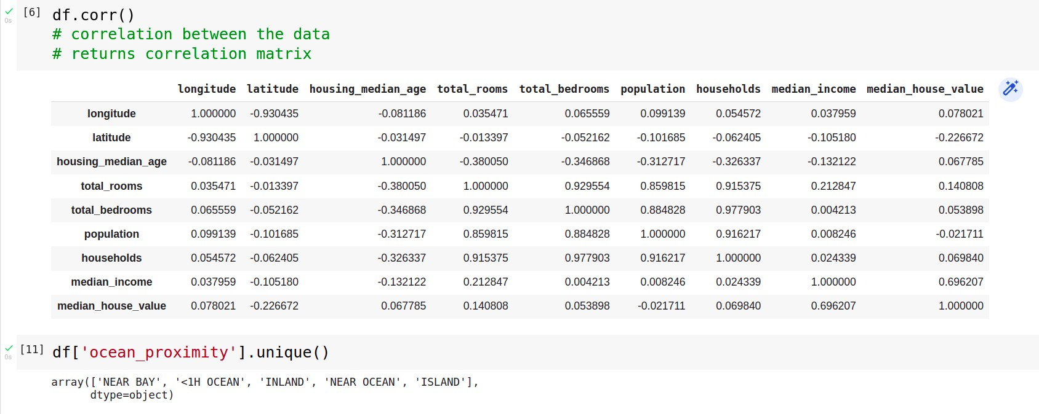

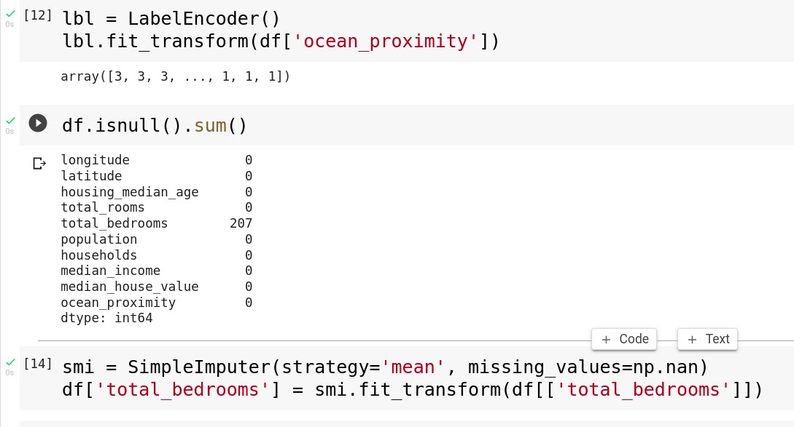

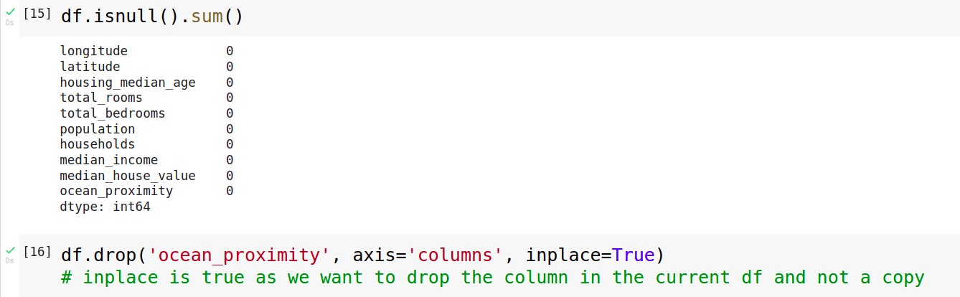
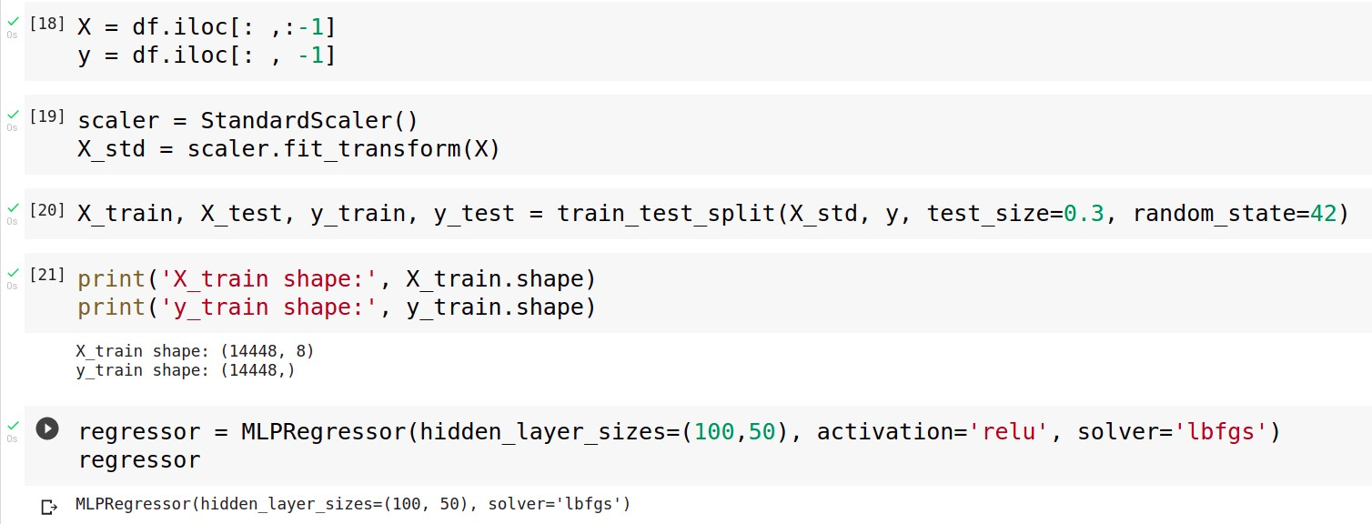

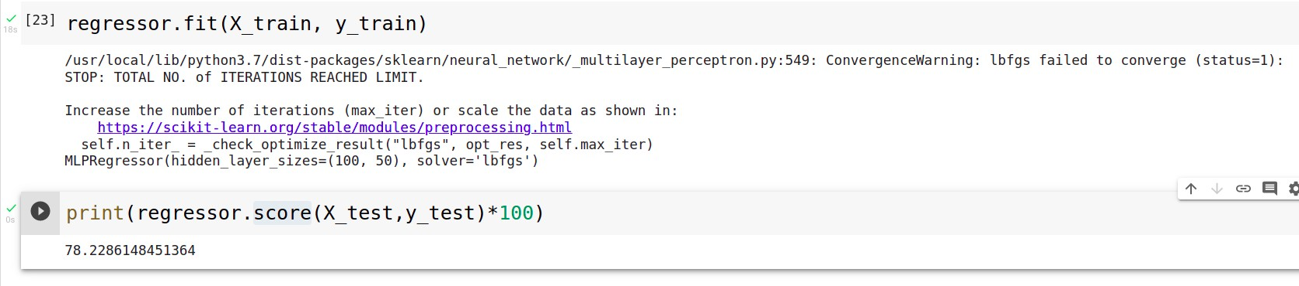

MLP Classifier:
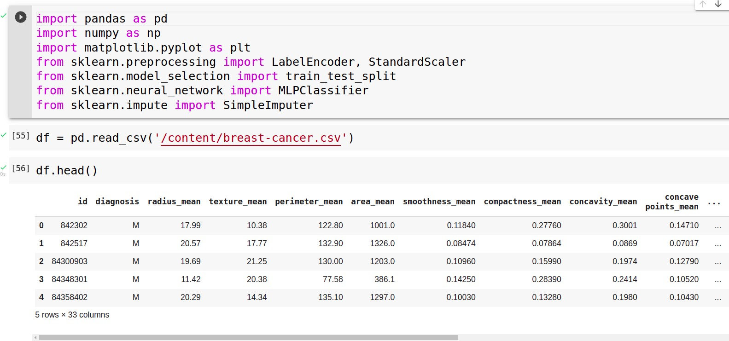
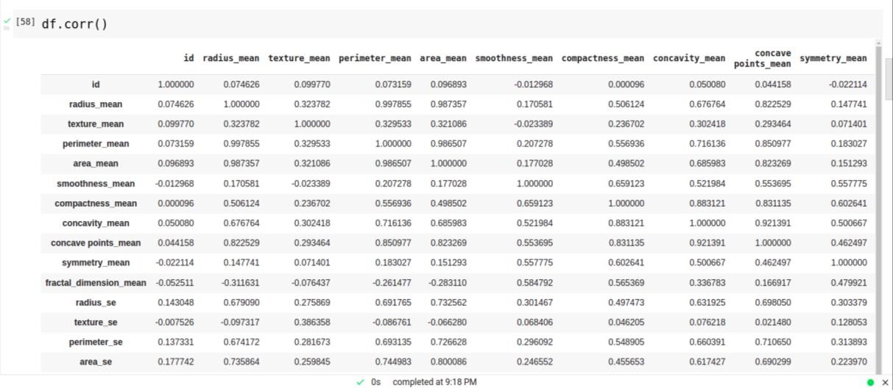

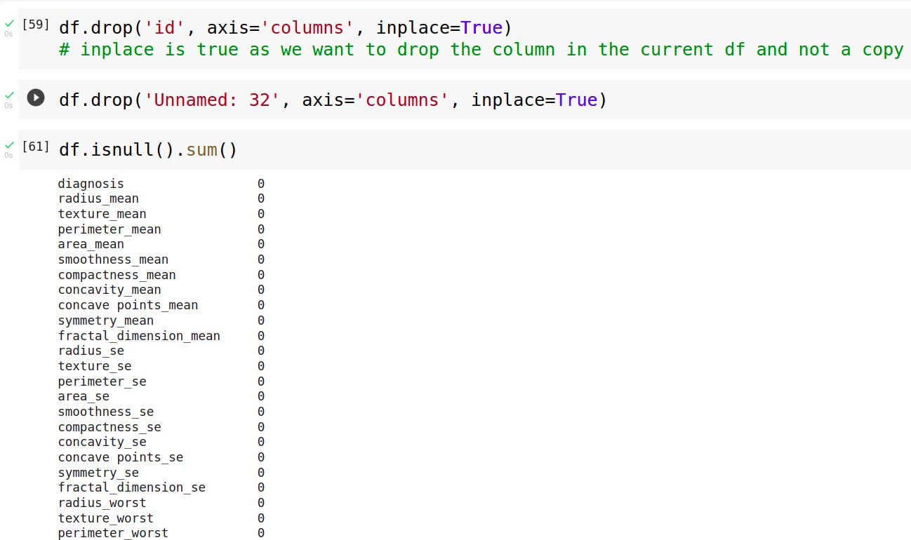
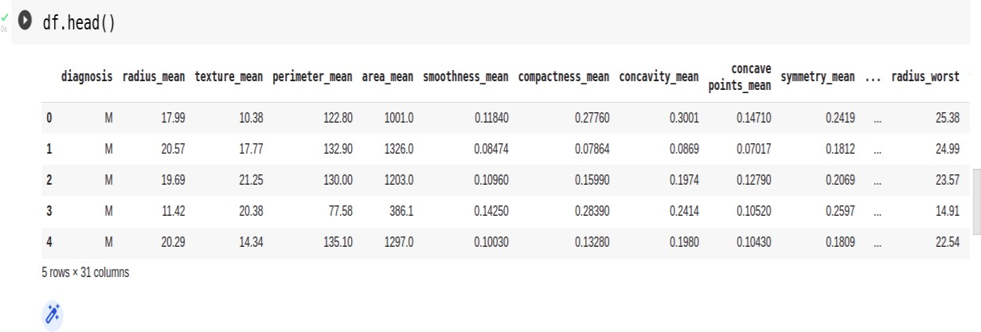
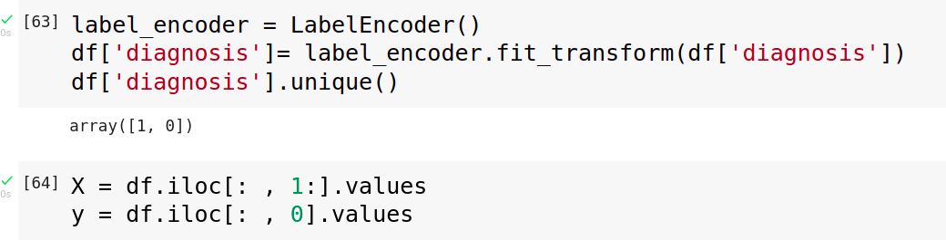
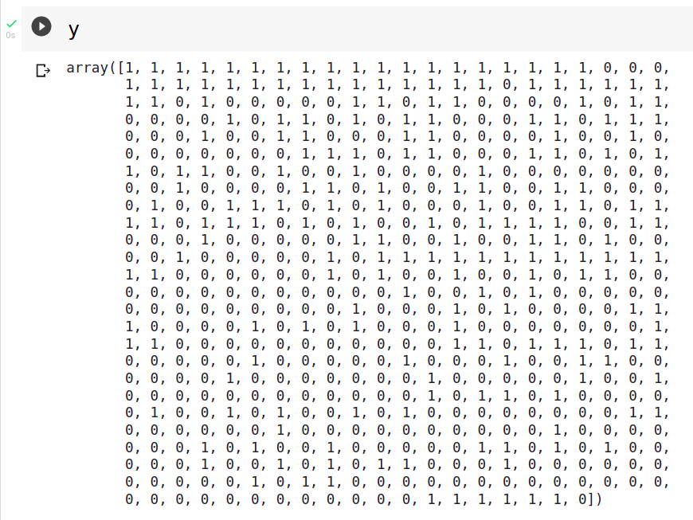

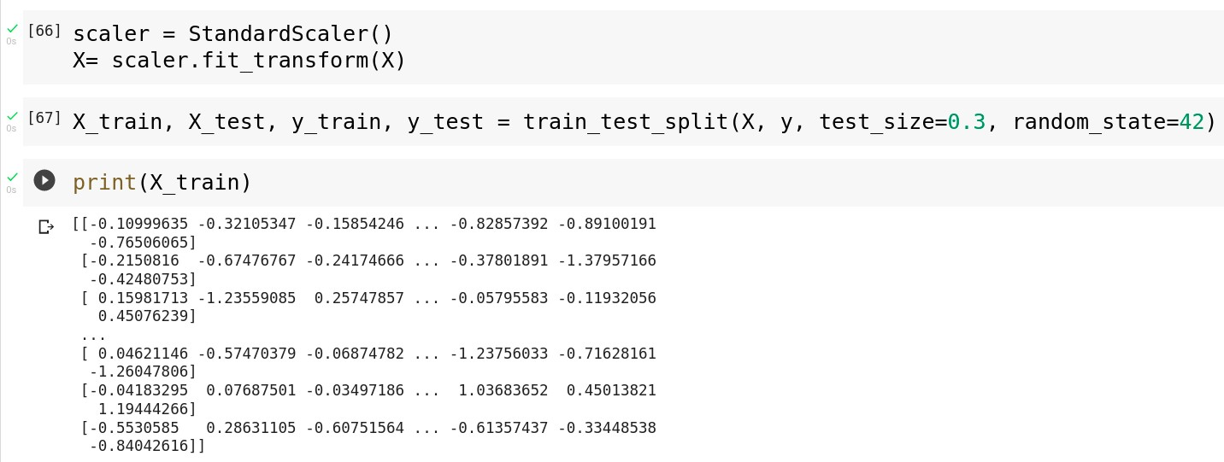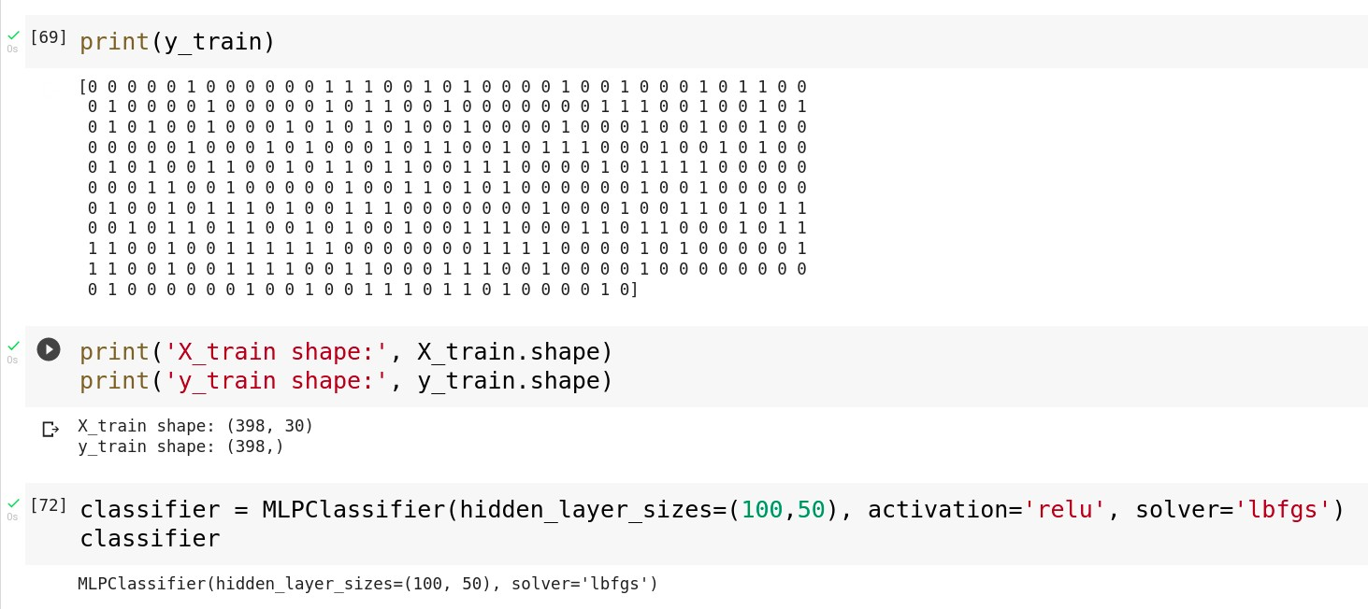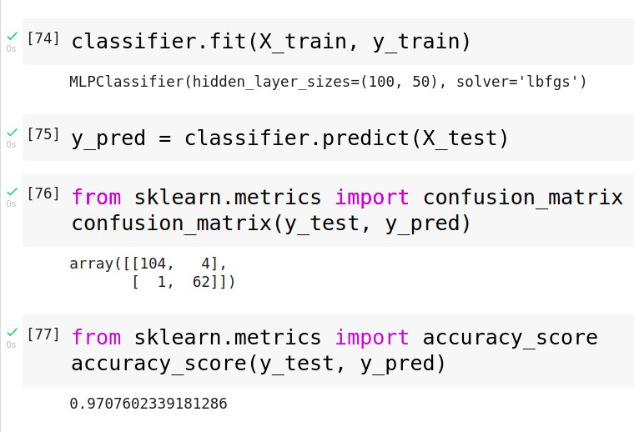

Conclusion
Thus we have successfully completed the implementation of Multilayer perceptron.

ASSIGNMENT 4

Aim: Develop a Bayesian classifier on any dataset

Objectives:
- To learn bayes theorem
- To implement Bayesian classifier

Theory
- Bayes Theorem:
⇒ Bayes’ Theorem is a way of finding a probability when we know certain other probabilities.
⇒ Formula:
where A and B are events and P(B) ≠ 0.

⇒ Basically, we are trying to find the probability of event A, given that event B is true. Event B is also termed as evidence.
⇒ P(A) is the priori of A (the prior probability, i.e. Probability of event before evidence is seen). The evidence is an attribute value of an unknown instance (here, it is event B).
⇒ P(A|B) is a posteriori probability of B, i.e. probability of event after evidence is seen.

- This tells us: how often A happens given that B happens, written P(A|B),
- When we know: how often B happens given that A happens, written P(B|A)
- and how likely A is on its own, written P(A)
- and how likely B is on its own, written P(B)

Bayesian classifier:
⇒ A Bayesian classifier is a probabilistic model where the classification is a latent variable that is probabilistically related to the observed variables.
⇒ In machine learning, naïve Bayes classifiers are a family of simple "probabilistic classifiers" based on applying Bayes' theorem with strong (naïve) independence assumptions between the features.
⇒ They are among the simplest Bayesian network models, and they could be coupled with Kernel density estimation and achieve higher accuracy levels.

Code and Output:

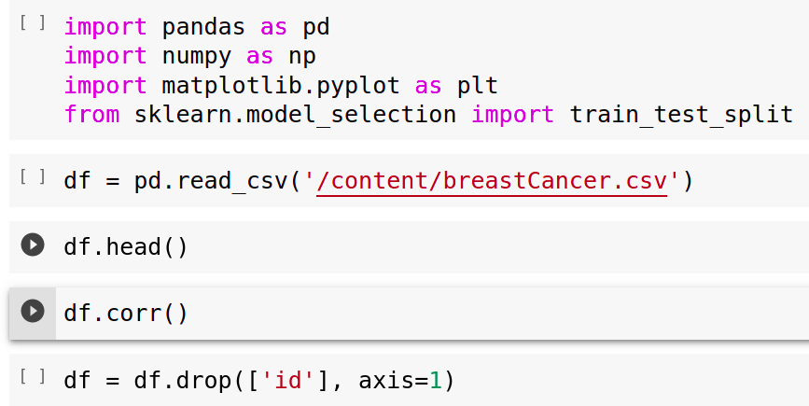

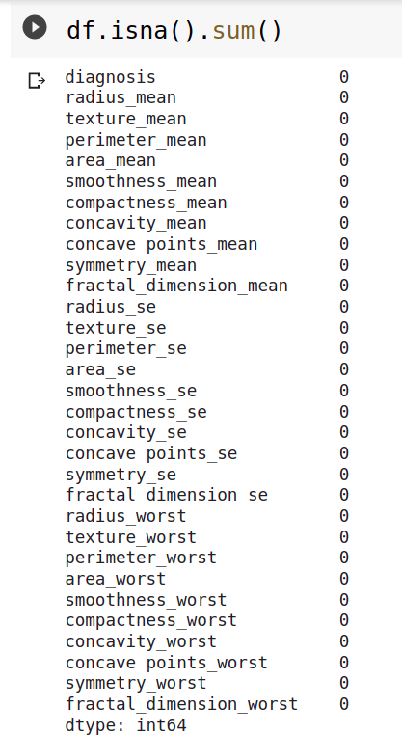
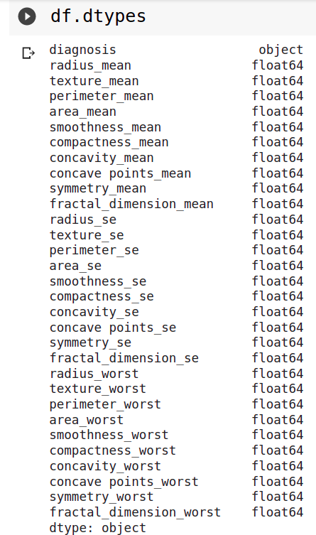

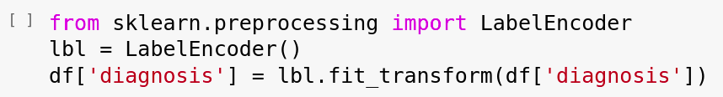

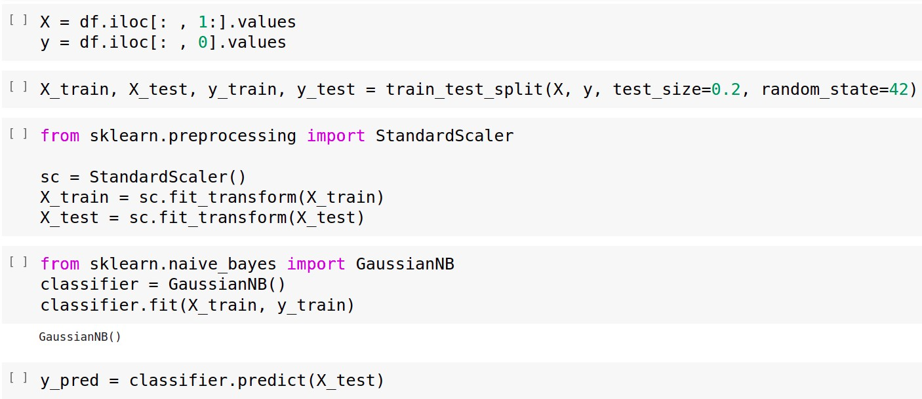
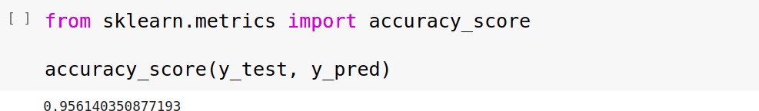

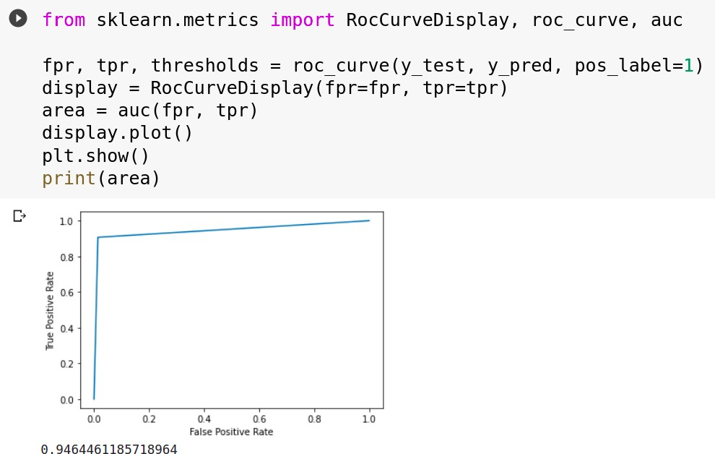

Conclusion:
Thus we have successfully completed the implementation of Naïve Bayes Gaussian Classifier.

ASSIGNMENT 5

Aim: Implement SVM Classifier or Regression for given dataset

Objectives:
- To learn SVM and kernel functions
- To implement SVM classifier

Theory:
- SVM:
⇒ support-vector machines (SVMs, also support-vector networks) are supervised learning models with associated learning algorithms that analyse data used for classification and regression analysis.
⇒ Given a set of training examples, each marked as belonging to one or the other of two categories, an SVM training algorithm builds a model that assigns new examples to one category or the other, making it a non- probabilistic binary linear classifier.
⇒ An SVM model is a representation of the examples as points in space, mapped so that the examples of the separate categories are divided by a clear gap that is as wide as possible.
⇒ New examples are then mapped into that same space and predicted to belong to a category based on the side of the gap on which they fall.
⇒ In addition to performing linear classification, SVMs can efficiently perform a non-linear classification using what is called the kernel trick, implicitly mapping their inputs into high-dimensional feature spaces.
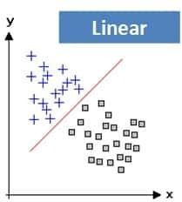
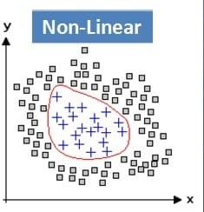

Kernel function:
⇒ Kernel Function is a method used to take data as input and transform it into the required form of processing data.
⇒ Kernel Function generally transforms the training set of data so that a non-linear decision surface is able to transform to a linear equation in a higher number of dimension spaces.
⇒ Major Kernel Functions:
  - Gaussian Kernel
  - Gaussian Kernel Radial Basis Function (RBF)
  - Sigmoid Kernel
  - Polynomial Kernel
  - Linear Kernel

Kernel trick
⇒ A Kernel Trick is a simple method where a Non Linear data is projected onto a higher dimension space so as to make it easier to classify the data where it could be linearly divided by a plane.
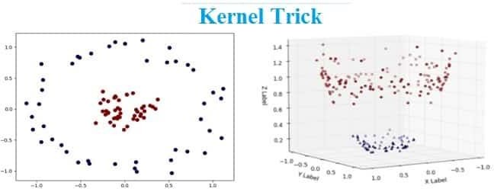

Significance of SVM
⇒ It is capable of doing both classification and regression.
⇒ By presenting the problem in terms of the support vectors. we can apply the kernel trick to effectively transform the SVM into a non-linear classifier.
⇒ SVM works relatively well when there is a clear margin of separation between classes.
⇒ SVM is more effective in high dimensional spaces.
⇒ SVM is effective in cases where the number of dimensions is greater than the number of samples.
⇒ SVM is relatively memory efficient.
⇒ Non-linear SVM means that the boundary that the algorithm calculates doesn't have to be a straight line. The benefit is that you can capture much more complex relationships between your data-points without having to perform difficult transformations on your own.

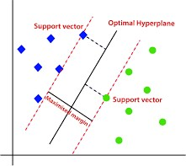

Code and Output:

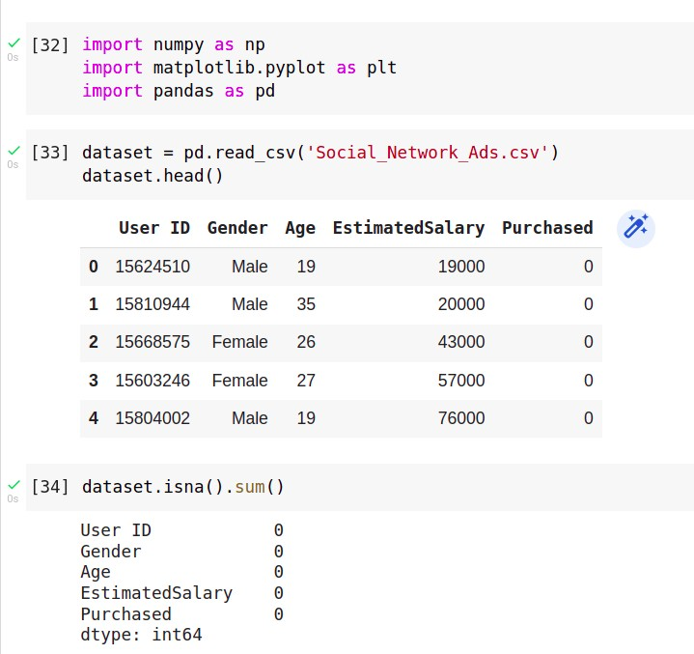
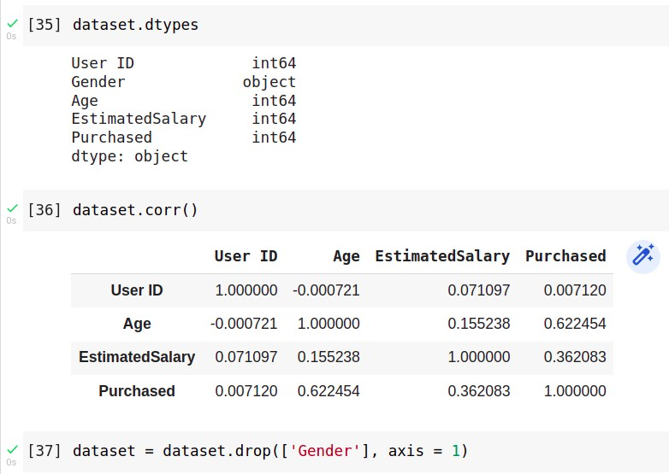
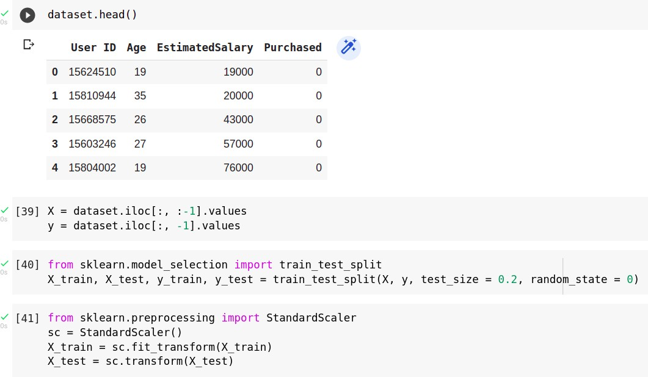

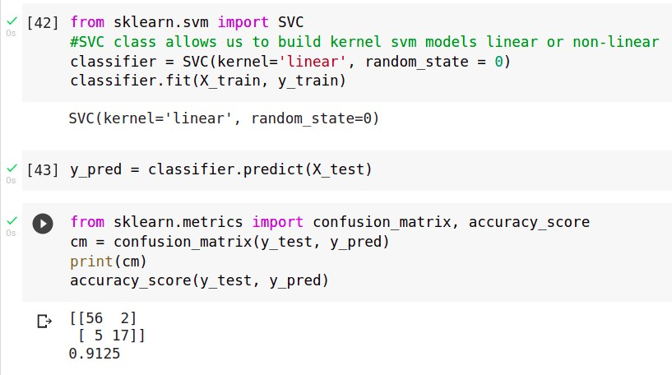
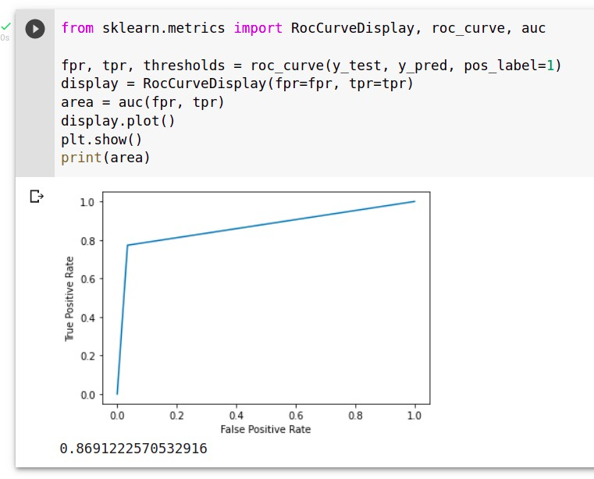
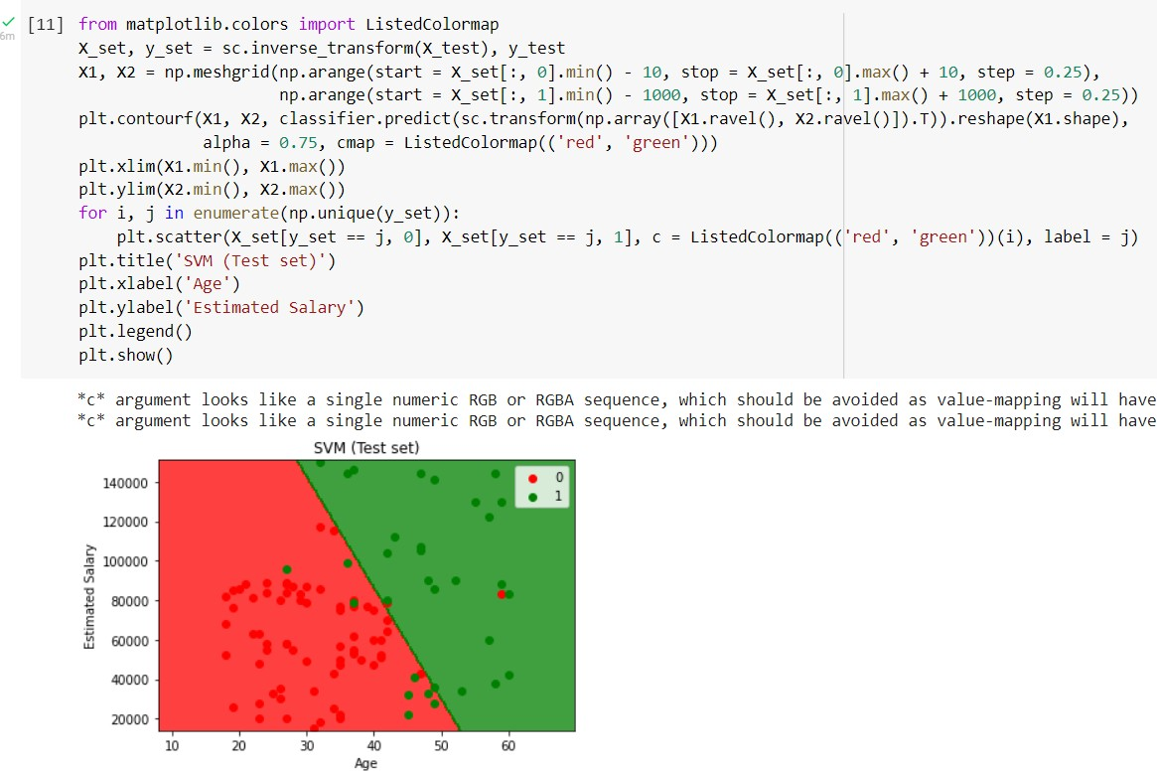

Conclusion:
Thus we have successfully completed the implementation of Support Vector Machine

